# Grocery basket in multiple currencies

## Introduction

This is an informal guide for this web application that implements the calculation of a grocery basket based on specific products and also the conversion of the final basket value to multiple currencies.

## Environment

The technology stack / environment / OS used, are the following:

* HTML & CSS (Bootstrap v3.3.7)
* AngularJS v.1.3.16
* Netbeans 2017.1.2
* NPM v. 3.10.10
* Protractor v. 5.1.1
* ChromeDriver 2.29
* Tested on Chrome 58.0.3029.96 (64-bit)
* Windows 10

In order to run this application, you need to go to the root folder of this project and type **‘npm start’**. This will download and install all the necessary node_modules and start the server. After the server has started you can go to **‘http://localhost:8000/’** and start using the application.

In order to run the tests (located in src/test/e2e/scenarios.js) you need to go to the root folder of this project and type **‘protractor src/test/javascript/protractor-conf.js’**.

## Functionality

The functionality has been implemented in 3 distinct steps.

### Step 1

The User can add products in the basket in the following ways:

* By clicking on the product icon.
* By using the **‘+’** button to increment to the quantity required.

The User can remove products from the basket by clicking on the **‘-‘** button. When the quantity is **‘0’**, this product is not included in the basket.

### Step 2

When all the required products have been added to the basket (and their quantities are shown in their respective fields), the User can click on the ‘Checkout’ button to calculate the total cost of the basket in pounds (shown in Step 3).

To restart adding products from the beginning, the User can click on the ‘Clear’ button to clear out the basket.

Always remember that if the User adds any new products to the basket, the ‘Checkout’ button has to be clicked again so as to calculate the new total cost. This button actually controls the workflow of the application.

### Step 3

The calculated cost of the basket is shown here in pounds.

To convert the cost in another currency, the User simply clicks on the currency’s symbol and the conversion is performed based on the current rate from <jsonrates.com>. The initial cost in pounds is also shown for verification purposes.

## Documentation and unit tests

The documentation for this application is comprised of the following:

* This informal guide which gives information on the frameworks / environments used, the functionality implemented and certain notes & screenshots to consider.
* Comments in the source files. You can check, especially, the comments in the html / controllers / test files.
* 19 scenarios in scenarios.js, that are performed against all the buttons in the application and other various scenarios.

## Notes & Remarks

Unfortunately, the free subscription plan to <jsonrates.com> does not support Source Currency Switching. Thus, I can't send as a parameter something like '&source=GBP', to get the exact rate against the pound.

So, I have to change the basket cost from pounds to dollars first (according to USDGBP), and then change it to the required currency using the respective rate (e.g. USDJPY).

Not an efficient workaround, but hey.. you get what you pay :)

All the images are free for use.

## Screenshots

* Initial screen of the application with no products on the basket

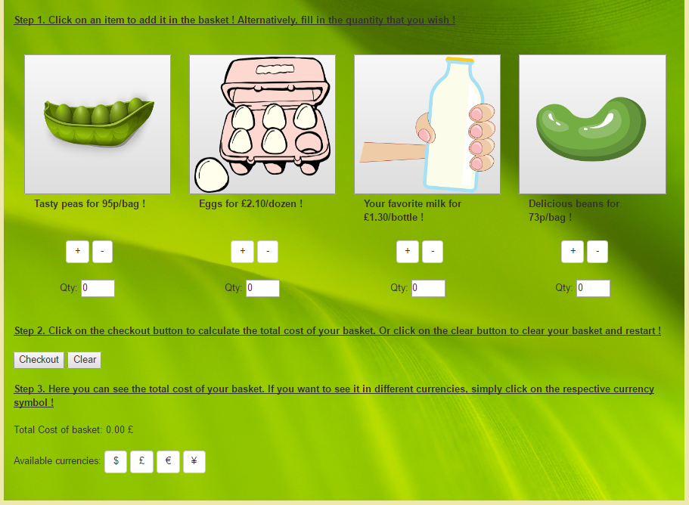

* 2 products added to the basket

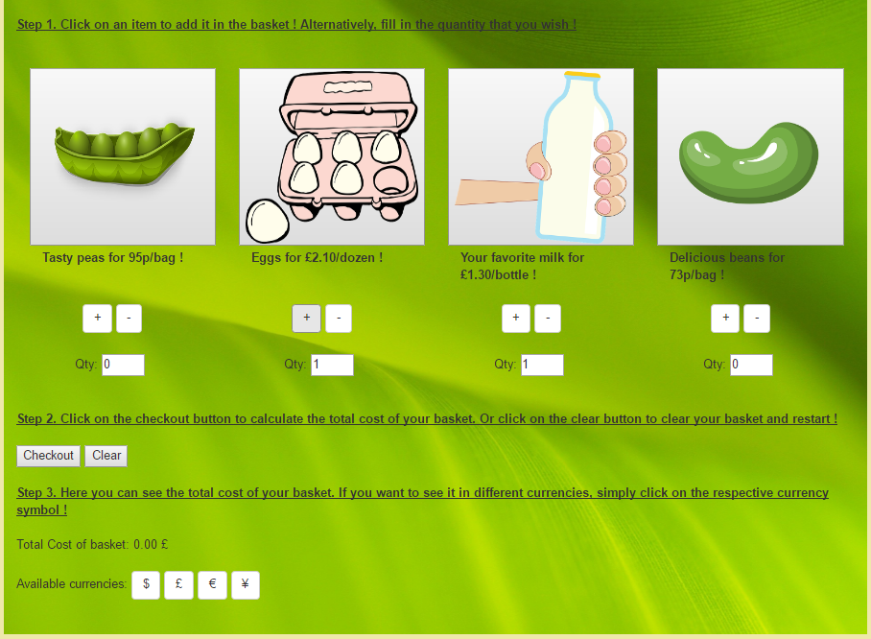

* 2 products added to the basket and the ‘Checkout’ button has been pressed. The total cost of the products is shown in Step 3.

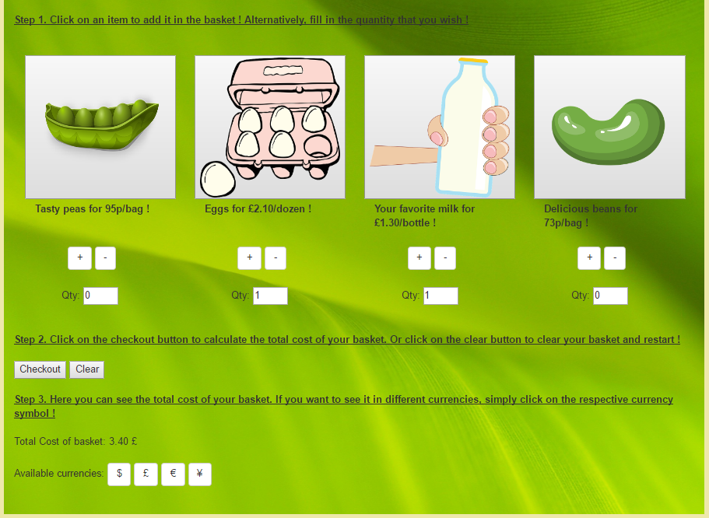

* Conversion to USD

